OUTPUT SCREENSHOTS:
1. Create all student, faculty, course, and department nodes with the given properties.
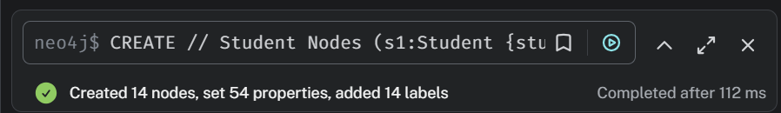
2. Create all the specified relationships with their appropriate directions.
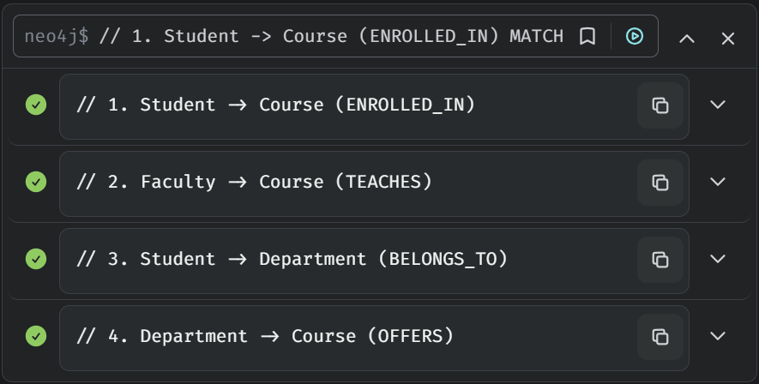
3. Assign properties to the ENROLLED_IN and TEACHES relationships.
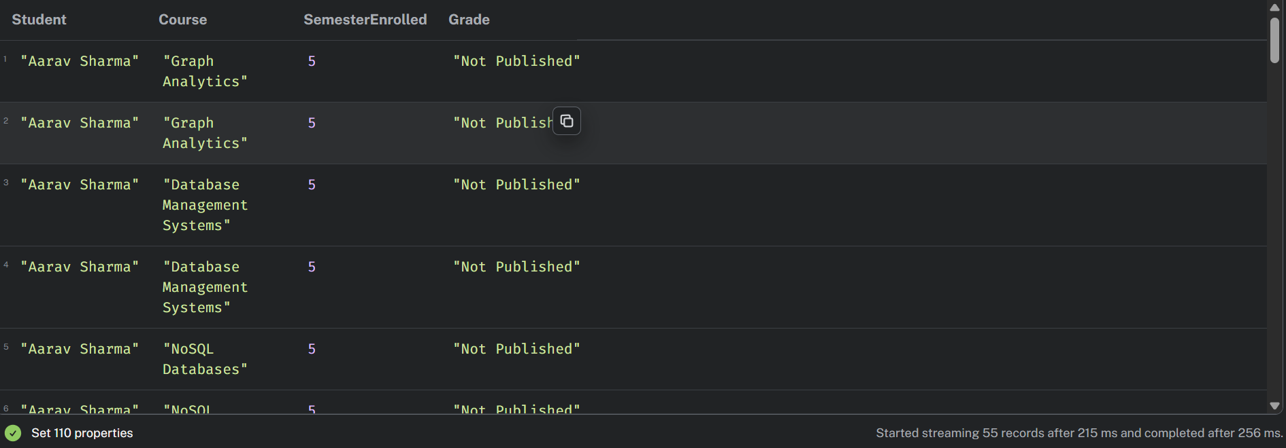
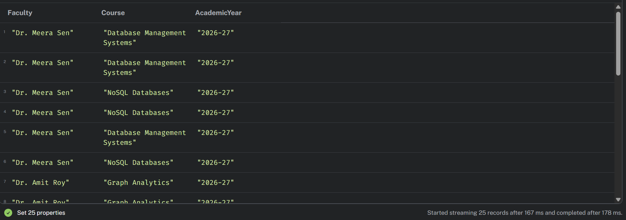
4. Display the complete graph.
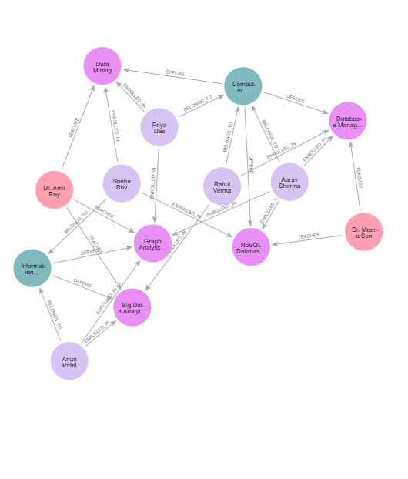

5. Count the number of nodes belonging to each label.
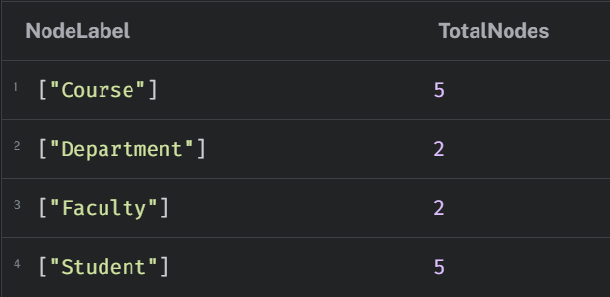
6. Display all relationship types and verify their directions.
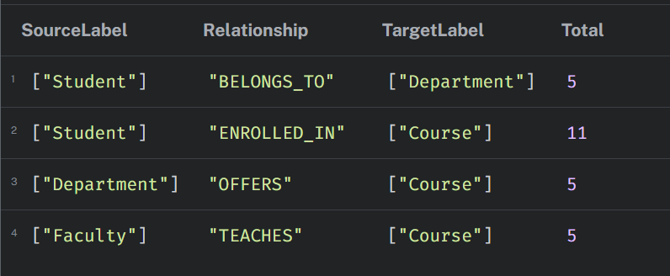
7. Retrieve all students studying in Semester 5
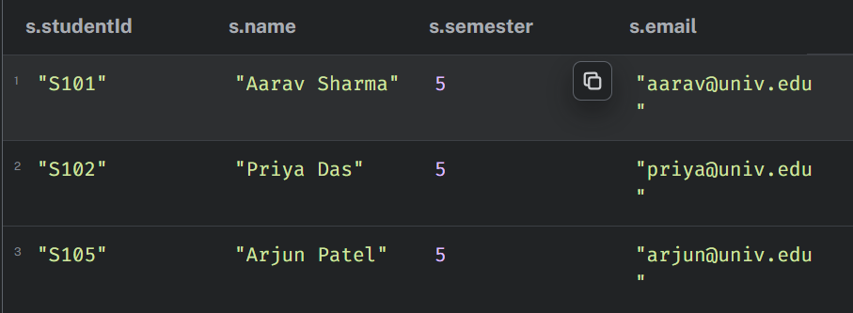
8. Find all courses with more than 3 credits.
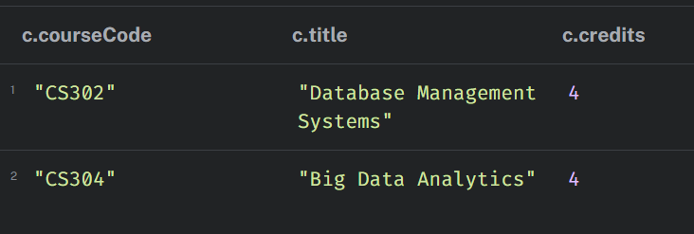
9. Retrieve the courses taught by Dr. Meera Sen
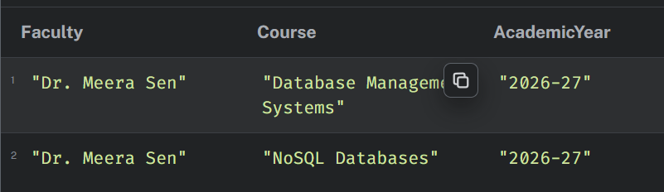
10. Find all students enrolled in Graph Analytics.
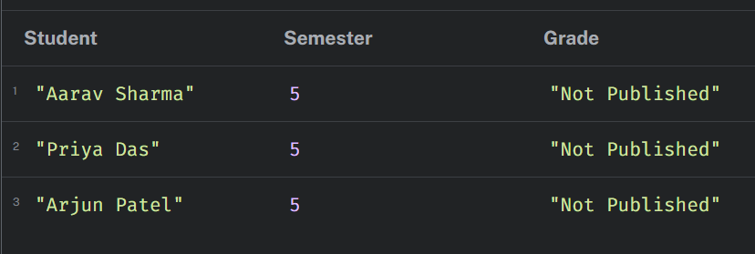
11. Display the names of all students belonging to the Computer Science department.
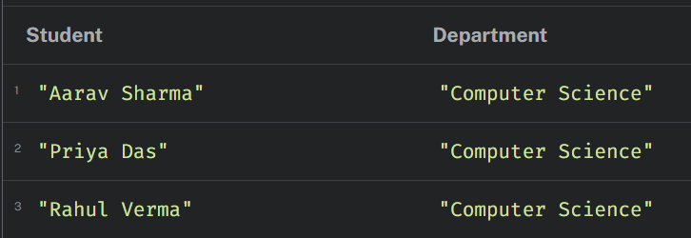
12. Find all courses offered by the Information Technology department.
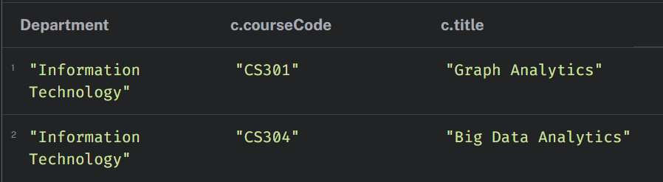
13. Retrieve all students enrolled in NoSQL Databases along with their semester and grade.
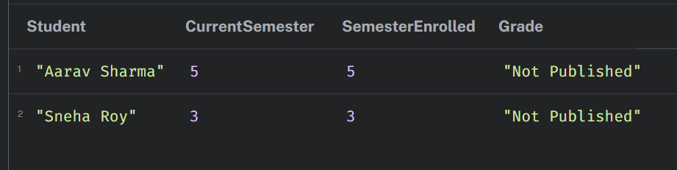
14. Find all students enrolled in both Graph Analytics and another course.
